13



14

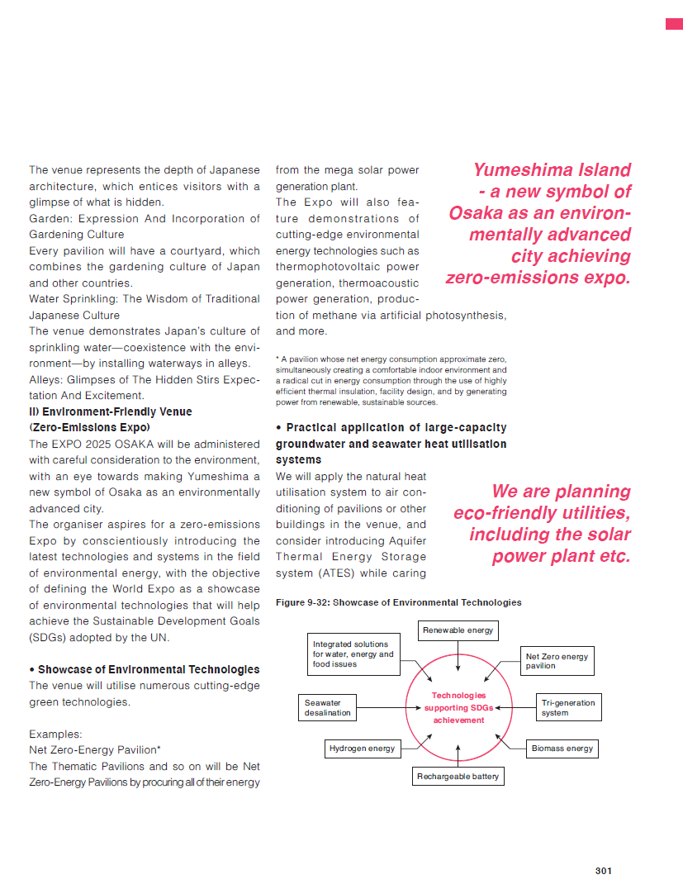

Chapter 9 VENUE CONCEPT

9.C Venue Design: Overview and Concept of Facility Arrangement and Installation

2) Concept for Facility Set-Up

b) A Venue in Harmony with the Environment

15

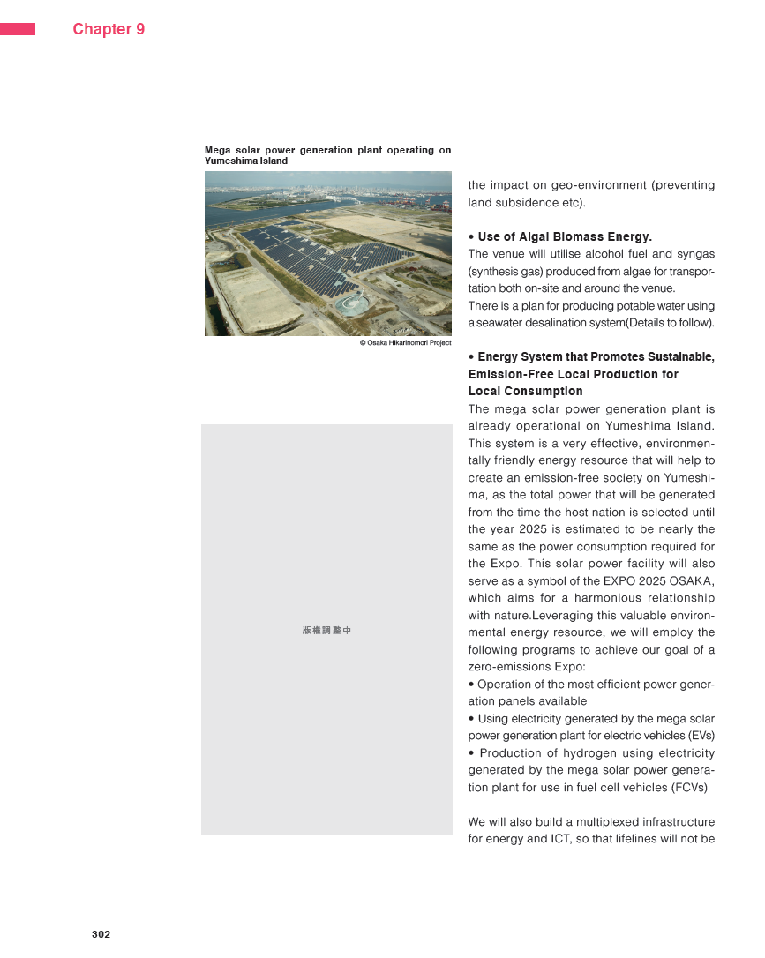

16

